**DAILY ONLINE ACTIVITIES SUMMARY**

|  |  |  |  |  |  |  |  |  |
| --- | --- | --- | --- | --- | --- | --- | --- | --- |
| **Date:** | **22/05/2020** | | | | | **Name:** | **Nivedita** | |
| **Sem & Sec** | **4th sem/a- sec** | | | | | **USN:** | **4al18cs053** | |
| **Online Test Summary** | | | | | | | | |
| **Subject** | | **Operating system** | | | | | | |
| **Max. Marks** | | **30** | | **Score** | | | **23** | |
| **Certification Course Summary** | | | | | | | | |
| **Course** | **Cloud and virtualization concepts** | | | | | | | |
| **Certificate Provider** | | | **VMware** | | **Duration** | | | **9 hours** |
| **Coding Challenges** | | | | | | | | |
| **Problem Statement: Write a C or Java program to implement round robin type of process scheduling** | | | | | | | | |
| **Status:done** | | | | | | | | |
| **Uploaded the report in Github** | | | | | **yes** | | | |
| **If yes Repository name** | | | | | [**https://github.com/nivi-nivedita/lockdown-coding-program**](https://github.com/nivi-nivedita/lockdown-coding-program) | | | |
| **Uploaded the report in slack** | | | | | **yes** | | | |

Online Test Details: todays test was OS for 30 marks. Module 1 for test taken by Harshitha mam.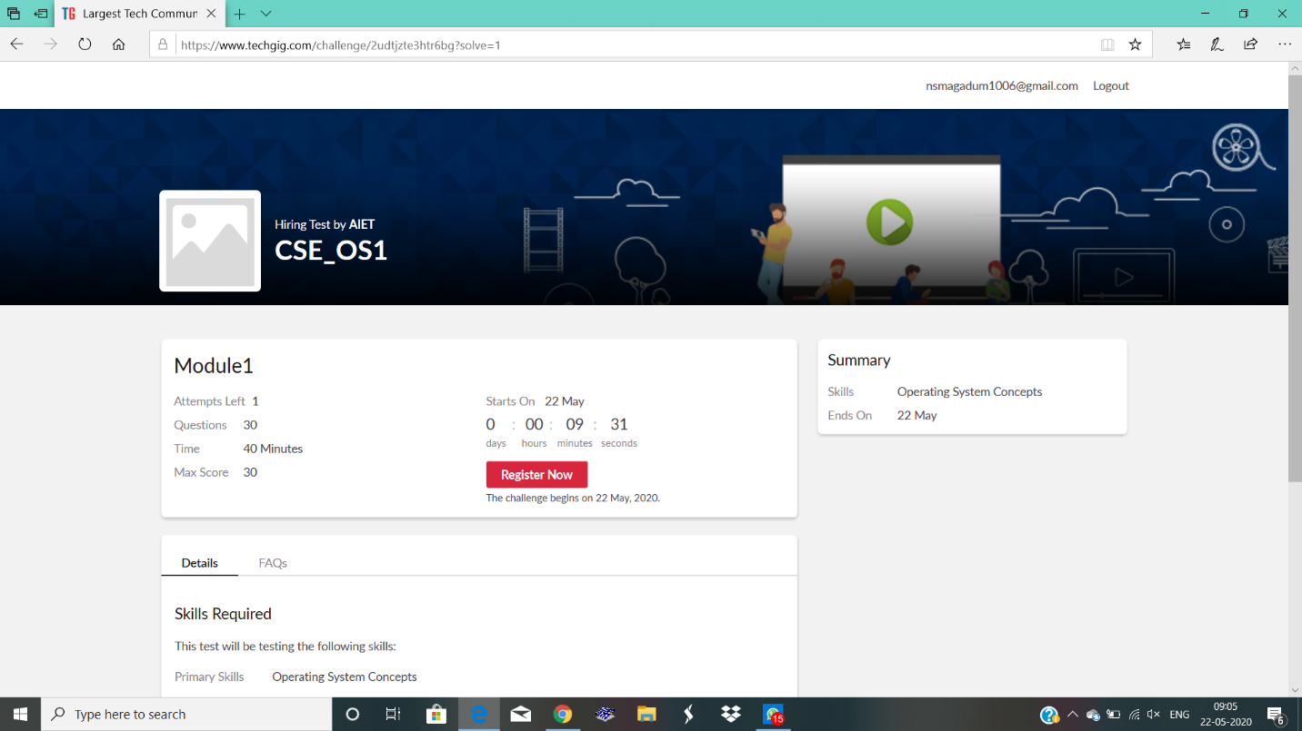

Certification Course Details: I continued course of cloud and virtaulization concepts. Which is finished by no certificate only badge I got from VMware. Its contain labs also for our reference.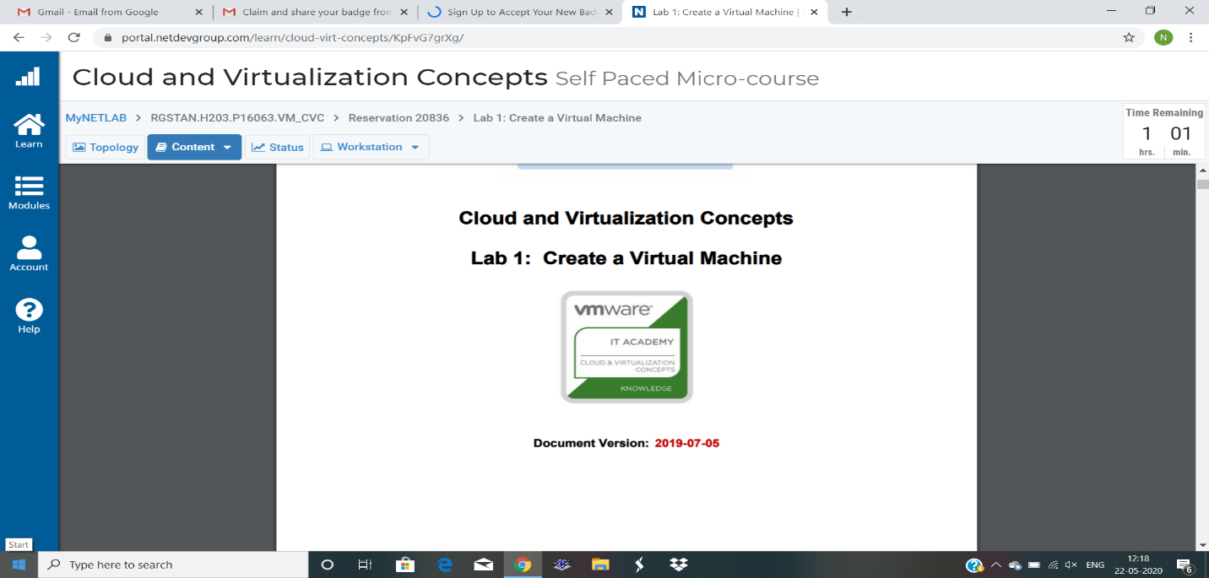



Coding Challenges Details: Write a C or Java program to implement round robin type of process scheduling .

With output.

. 